**M5D0AM – M6D57PM (diluted 1:1000)**

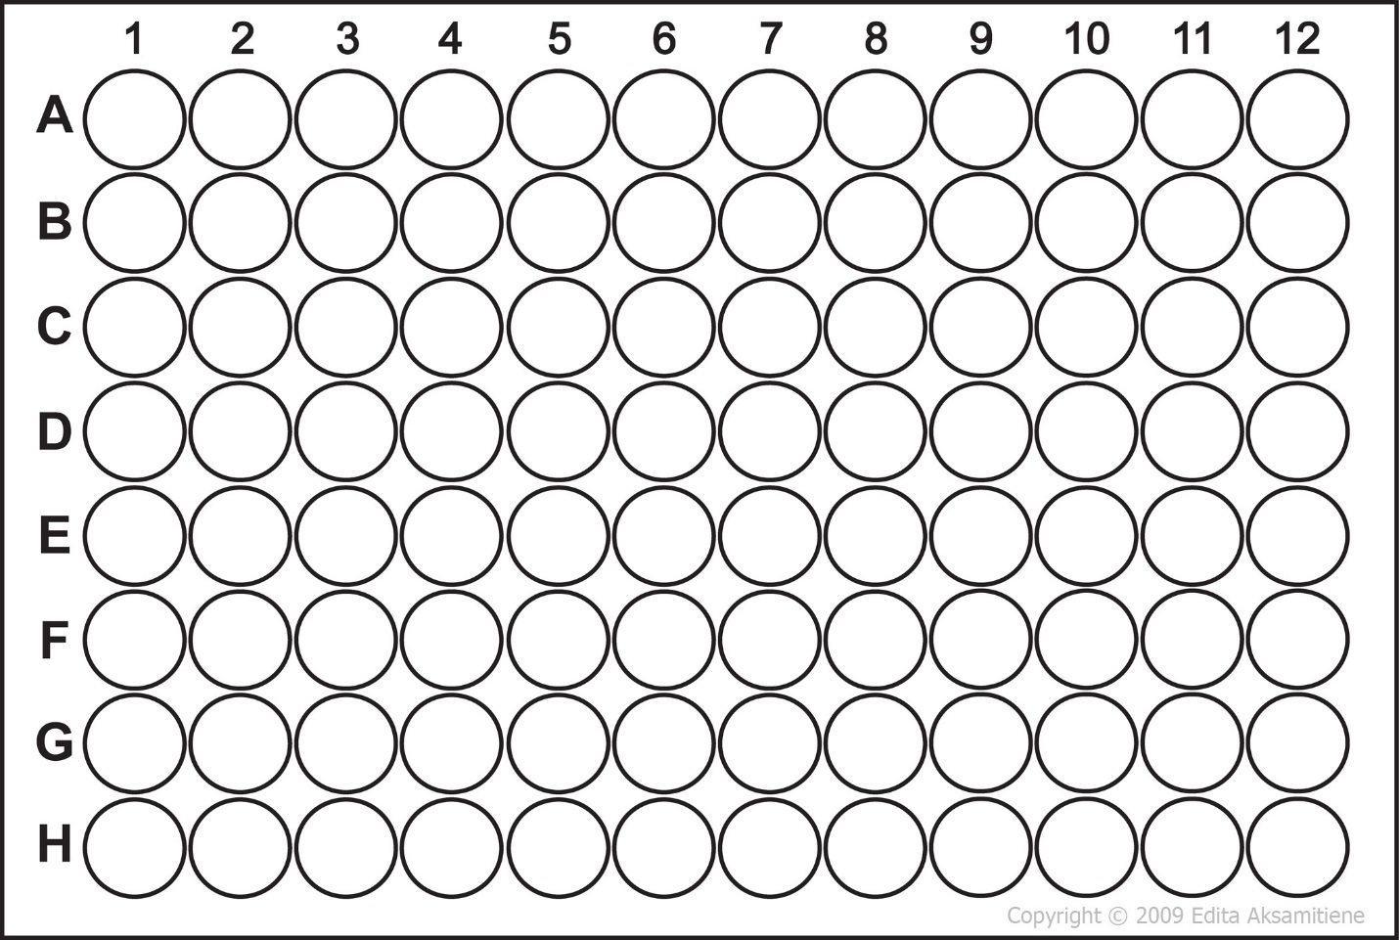

6d57pm

5d57pm

9d25

1d2pm

9d2pm

10d2pm

6d3am

5d3pm

1d4am

3d4am

4d4am

7d4am

9d4am

3d4pm

6d4pm

1d8

2d8

3d8

4d8

7d8

8d8

10d8

4d9

6d9

9d9

10d9

6d10

7d10

6d11

8d11

10d11

10d14

6d16

9d16

4d57pm

3d57pm

10d57am

9d57am

8d57am

7d57am

9d2am

8d2am

7d1pm

8d21pm

8d24

2d24

7d23am

1d23am

8d22pm

9d22am

6d22am

10d21pm

2d21pm

5d57am

4d57am

3d57am

2d57am

4d64pm

9d64am

7d64am

3d64am

2d64am

9d63

8d63

6d63

2d63

6d54

5d54

3d52am

9d50pm

2d45pm

3d44pm

2d42pm

7d28pm

6d28pm

6d28am

10d25

8d25

9d24

10d21am

7d18

8d18

9d18

1d21am

2d21am

3d21am

6d21am

7d21am

7d1am

6d1pm

3d1am

2d1am

10d0am

5d0am

(1:10